Dear Parent/Carer

**Monifieth High School Christmas Newsletter 2013**

I would like to take this opportunity to thank you for your continued support throughout the year. When writing to you, I intend to continue my theme of using our three priorities for the school which are **Attainment, Community** and **Health.** You will ‘see’ in this very pictorial newsletter we have been doing lots under these priorities.

It has been a very busy couple of terms with the introduction of the new National qualifications. I am pleased to report that both pupils and staff have risen to this challenge and feedback from all subjects sampled from Monifieth High School is we have passed the first round of SQA verification of new National Qualifications. Curriculum leaders are confident that their planning is on course and at this time classroom teachers are preparing pupils in the Senior Phase for prelims and internal unit assessment. Currently teaching staff are engaged in development work for scheduled implementation of new Highers in 2014/2015.

As well as planning for the new courses in the Senior Phase this has been a period of considered reflection on the newly implemented Broad General Education (BGE) in S1-3. We will in due course be in consultation with all parents and pupils.

As ever, our aim is to update you on the many of the exciting achievements happening with our pupils. I am proud to introduce this ‘snapshot’ as my first official newsletter (an unabridged version is available on the website) and in recognition of this you will notice that it has been printed in colour. You will appreciate that this is expensive and not eco-friendly so future newsletters will be available via the school website. We are also considering using email to improve communication. In order to do so, we will, where applicable, require email addresses. There is reference to this proposal at the end of the unabridged version of the newsletter available on the website.

Finally, on behalf of all the staff at Monifieth High School, I wish you and your families a very Merry Christmas and all the best for a Happy New Year.

Yours sincerely

M-C McInally

Head Teacher

December 2013

**ATTAINMENT**

On 4th September, parents of S1 pupils were invited to attend an information evening aimed at providing information and advice about supporting a pupil in S1 at Monifieth High School. This provided them with advice on how they can best support their children with their learning in secondary school, active learning in the secondary classroom, communication via the diary planner and homework. As always parents can contact their child’s PT Pupil Care & Support or DHT to discuss any concerns.

Our P7 Open Evening on the 30th October brought together parents and pupils who may join us in the new S1 in August 2014. We had the best turn out of recent years and the P7 pupils and their parents enjoyed seeing departments in action, for example sampling baking, participating in art, music and science and finding out about the curriculum in all departments. We had our first ever crèche staffed by our Early Education and Childcare class and many of our pupils led presentations. The feedback was excellent and in particular praised the leadership of our pupils.

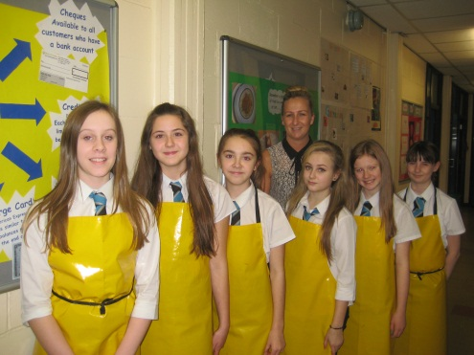

We have many additional extra-curricular activities that help to support learning in the school. In addition our supported study classes run most lunchtimes and after school:

<http://www.monifiethhigh.angus.sch.uk/page83.html>

The S1/S2 Homework Club runs every Wednesday and has a regular group attending which is supported by Miss Stevenson and Miss Kelly.

S1 Book Club is available every Monday in the library with Mrs Robb and Laura Stewart, Senior Public Library Assistant and encourages young people to read and talk about what they are reading.

Debating Club for (S1-3) runs every Monday lunchtime and is facilitated by Miss McCumiskey. Some of the topics that they have covered are: Homework, School Uniform, Scottish Independence amongst other things.

SCHOLAR is a resource from Herriot Watt University to support senior pupils in Higher and Advanced Higher in Maths, Sciences, Business Education, Psychology, Computing, Info Systems and Modern Languages all S5 pupils received their induction in August and have logins, if your son/daughter requires another one they should notify their Form Tutor or PTPCS. It is an excellent resource and is invaluable if your son or daughter is ‘stuck’ on a question at the weekend or in the evening as a tutor is available to assist online with any queries.

**Uniform**

I would once again like to thank all parents for your continued support of our uniform policy. Visitors to the school, local residents and those who see our pupils when they are out of school regularly comment on how smart they look and they are indeed a credit to their families. The vast majority of pupils comply fully with our uniform policy at all times. Recently, however, we have had to remind some pupils that certain items of clothing or footwear such as hoodies or other tops (even black) that obscure their shirt and tie, jeans (even black) and trainers are not acceptable for school.

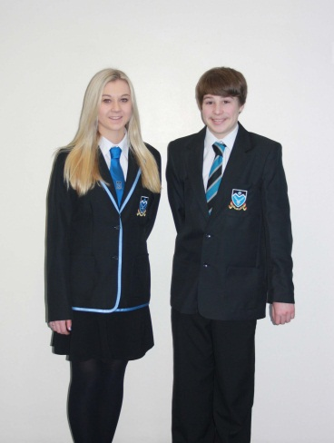

Can I remind everyone that school uniform consists of black shoes, black dress trousers or skirt, white shirt and a school tie. Plain black v-neck jumpers and cardigans that do NOT obscure the shirt and tie are also acceptable.

I very much appreciate your support in ensuring that your son or daughter is dressed appropriately so that our pupils continue to be positive representatives of our school in the local community.

I ask that blazers be worn to school under winter coats, which should then be removed in school.

**English Department visits**

The English Department at Monifieth High School organised a variety of events for pupils to bring their learning in class to life.

A group of 100 senior pupils attended a screening of Shakespeare’s Othello at the DCA.  This trip, which was organised by their class teacher allowed the pupils to witness on screen what they have been studying this year in class.  This production, which is a new release by the National Theatre Company, depicts the destructive power of jealousy and starred actors Adrian Lester and Rory Kinnear.  The director based his modern version of Othello on a contemporary military base, which served to remind pupils of the situation across the world today.  This film was well reviewed by the Daily Telegraph and the Metro, and pupils from Monifieth High School found it very engaging and interesting.  Overall, it helped bring their coursework to life.

A group of 70 S3 pupils also visited the DCA as part of the Discovery Film Festival to watch Private Peaceful.  This film tells the story of two brothers whose lives are dramatically altered by the outbreak of WW1.  As the S3 pupils have been looking at First World War poetry by Wilfred Owen as part of their course, this film helped put the situation into clearer perspective for the young people and was enjoyed by all involved.

The Scottish Youth Theatre visited Monifieth High School to perform a play to all S1 and S2 pupils.  The purpose of the visit was to introduce the topic of drama to the young people and give them an insight into stage setting and creativity.  The S1 and S2 pupils watched a short production then took part in a workshop in which they were encouraged to write short plays of their own.  Many pupils thoroughly enjoyed this event very much and have gone on to apply to the Scottish Youth Theatre Summer School.

**Monifieth High School’s New Acting Club**

This new club, led by a team of S6 pupils including Georgia McAllister and Lorna Murphy, aims to build the confidence of S1-3 pupils in their acting abilities. The club members will also learn about what happens on a film set and are taught different acting techniques that are used in the business. The club has just started this session and is proving to be a great success with all participants. The club is always looking for more members and information is available from the noticeboard about future meetings and joining the club.

**Zoolab**

On Tuesday 26th November, Zoolab visited the Geography department to give workshops to S1 classes about the rainforest. S1 this term have been studying the rainforest location, structure and climate and looking at the ways of life of the local tribes. This workshop gave them the chance to see and touch the animals that had been spoken about. There were a variety of live animals including stick insects, cockroaches, spiders, frogs and snakes. They were told about each of their habitats and how the rainforest and these habitats are under threat from humans. The importance of conservation was also discussed. It was an enjoyable and successful day for all involved and we look forward to seeing them again next year.

**School Captains**

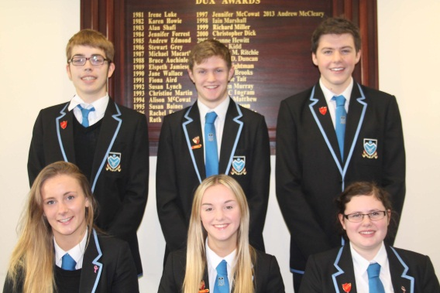Pictured here is our captaincy team for this session. A large number of our prefects applied for the positions of captain and vice-captain and the selection process was a rigorous one. This included an application form, individual presentations and an interview by a panel.

The Captains for 2013/14 are Hannah Cooper and Thomas Doig and the Vice-Captains are Christy Guthrie, Christopher Harris, Freya Marshall and Andrew McCleary.

**COMMUNITY**

**S6 Blood Donors**

Every year, pupils from Monifieth High School show their awareness of others by joining the blood donors register and donating blood for the first time. This year was no exception.  On Friday 27th September, 19 pupils went to the Ninewells Blood Donor Clinic, accompanied by PTPCS teacher Mr Burns.   The group were picked up by the minibus in the morning and were taken up to the Blood Donors Clinic where the staff assessed the young people and the benefits of becoming a blood donor were made clear to them.   For all the young people involved, this was their first donation and the staff at Ninewells were delighted by their maturity and by the sheer number of young people willing to donate their blood to help save the lives of others.

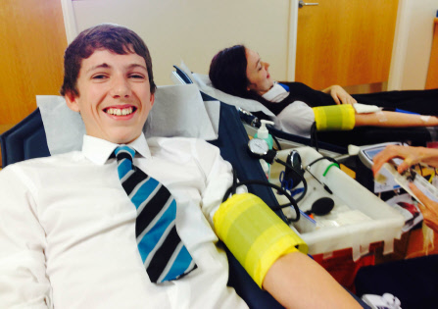

Commonwealth Games Queen’s Baton representatives from MHS are Bruce Philip and Andrea Goodman.

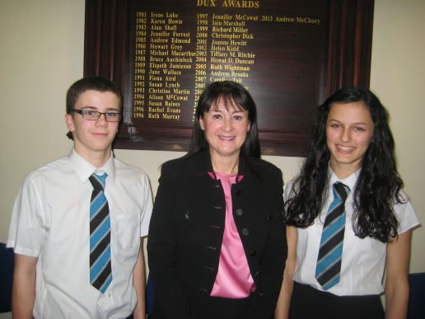

**Christmas Retirals**

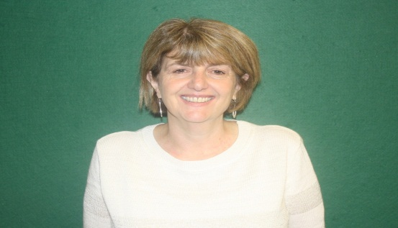Mrs Dobson, Principal Teacher of ASN is retiring at Christmas after 12 years working at Monifieth High School. The school wishes her all the very best for a long and happy retirement.

**CHARITY**

**Blythswood Shoebox appeal**

Pupils at Monifieth High School have again been involved in collecting items for the Annual Shoebox Appeal 2013 which is run by Blythswood Care.  The S2 Charities Team helped to organise the Appeal at Monifieth High School, which aims to give people of all ages the opportunity to receive gifts at Christmas in poorer countries such as Romania, Albania, Bulgaria and India.  The Charities team worked hard to encourage pupils to fill regular sized shoeboxes with items such as toiletries, new clothes, stationery, household goods such as candles, DIY items such as screwdrivers, stationary and sweets.   The appeal was very successful and the S2 Charities Team collected 69 shoeboxes.  These boxes are now on their way to help brighten the lives of those less fortunate than ourselves at Christmas.  Thanks to all who were involved in this worthwhile process.

As you know we have adopted the four values from the Scottish Mace as our school values (Integrity, Compassion, Justice & Wisdom) and in order to make the pupils think compassionately about others in our community they were invited to bring in £1 to help support our annual Senior Citizen Christmas Tea Dance. We hosted an afternoon of entertainment and dance and our guests went away with a beautiful planter (made in Technical, painted in Art and filled with bulbs grown in Science) as a present. All of the guests were thrilled with their gift and one said ‘it will brighten up the duller days of winter every time they look at it’.

**MacMillan Coffee Morning**

On Friday 27th September, the staff from Monifieth High School staff took part in ‘The World’s Biggest Coffee Morning.’  Through this event, the school raised £314.40 for Macmillan Cancer Support.  A range of delicious homemade cakes were baked by pupils in the school.  A raffle was also with a wide range of prizes to raise funds for McMillan Cancer Support.

**Monifieth Christmas Lights ‘Switch On’**

Monifieth Christmas Lights ‘Switch On’ saw our talented brass group perform Christmas carols for our wider community on a very cold evening. We were also performing at Dobbies on Thursday 12th December in the afternoon to entertain the shoppers and local community.

**Litter**

I have dealt with several complaints about litter in the surrounding areas of the school community and met with two Environmental Compliance officers and pupils have had several reminders to be ‘mindful’ of their actions concerning the responsible disposal of litter. It has definitely improved in the school with us seeing less littering and a cleaner environment for us to work in. I must also thank Miss Smith, DHT, and her S6 volunteers who have gone out on litter picks around the school as part of our community involvement initiative.

**Remembrance Service**

At the 11th hour on the 11th day of the 11th month, we held a very moving remembrance service in the school for sixth year pupils.  This was led and organised by the advanced higher History pupils Christopher Harris, Taylor Han, Nicola Clarke and Michael Craig along with Principal Teacher, Mr Hood and teachers Mrs Anderson and Mrs Whitfield.  The pupils gave background information about the Great War, the human cost of the conflict, the lasting effects on the families of the victims of War and the significance of the Poppy.  The senior pupils then spoke of their emotional visit to the First World War battlefields of Belgium and France where they visited the trenches and the graves of fallen soldiers, many of them who were the same age and younger than themselves.  S6 pupil Nicola Clarke recited the well-known poem ‘In Flanders Fields’ by Lieutenant Colonel John McRae, a doctor who was serving as a gunner and medical officer with the Canadian Expeditionary Force.  The touching poem was inspired by the burial of McRae’s close friend Alexis Helmer, and he noticed how quickly the poppies grew around the graves of those who bravely gave their lives in the conflict at Ypres.  Michael Craig then recited the ‘Ode to Remembrance’ from Laurence Binyon’s poem ‘For the Fallen’.  This was followed by the Last Post played by teacher Miss Low, two minutes silence in respect for those who have lost their lives in conflict and the Reveille.  S6 pupil Cameron Clemson closed the assembly by playing Highland Cathedral on the bagpipes.  This assembly was particularly emotional and impacted heavily on all pupils involved.

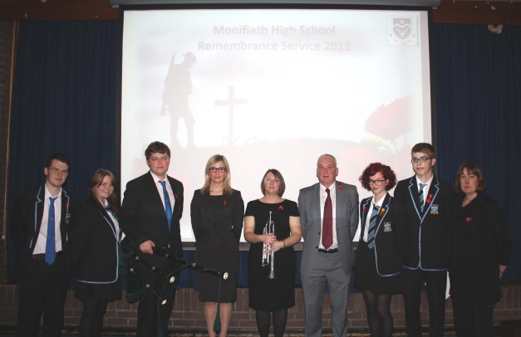

Michael Craig, Nicola Clarke, Cameron Clemson, Mrs Anderson, Miss Low, Mr Hood, Taylor Han, Christopher Harris and Mrs Whitfield

**Monifieth War Memorial Visit**

All S4 pupils who study History took part in a visit to the Monifieth War Memorial.  As part of their course, they have researched former pupils of Monfieth High School and the local area who have served their country and lost their lives.  Pupils were very interested and moved by the information that they found out and paid their respects at the War Memorial.  Here they laid Crosses of Remembrance and held a small ceremony.  The well know poem ‘In Flanders Fields’ was recited by S4 pupils, along with the ‘Ode to Remembrance’.  This was a very successful visit and pupils commented that they now had a greater understanding of the sacrifices of War.

Names of S4 who read out poems: David Goodfellow and Andrew Clarke

**HEALTH**

**Inter-House Competitions**

There have been a series of assemblies taking place to re-launch the inter-house championships between Monifieth High School’s three houses Balmossie, Dalhousie and Panmure.

Pupils were reminded that it is taking part that earns points, not just winning, so all pupils were encouraged to do their best to win points for their houses.  Points can be gained in a variety of ways, from sporting accolades to classroom merits, good homework and various achievements outside school.  Senior pupils will visit form classes regularly to find out about achievements and with information about events taking place in school.

Balmossie won the both the junior and senior house trophies last year.  The big question is…. who will win this year?

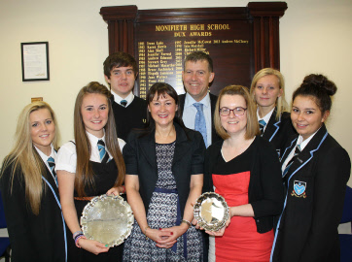

Photo:

Head Teacher Mrs McInally, Head of House Mr Morris and House Staff member Miss Wilson with some of the Balmossie House Team

**Health Drop-In**

The Principal Teachers Pupil Care and Support have teamed up with our Health professionals and partners to offer the pupils an opportunity to discuss or take part in activities in our Health Drop–In every Thursday lunchtime.

Topics cover Mental Health & Wellbeing, Sexual Health & Relationships, Cancer Awareness and Healthy Body, Healthy Mind and Healthy eating.

**Rotary – Future Chef Competition**

On the 19th November, a group of 5 pupils from S1 to S6 took part in an exciting competition organised by the Rotary Clubs. The task was to plan, prepare and cook a two course meal with a budget of £10. The entrants were fully committed to the task and worked very hard to produce creative, healthy and interesting dishes. This competition was judged by a group of Rotary Club members and was based on presentation and taste, budget, healthiness of the dish, theme (if there was one) and good time planning. The judges even looked at the choice of plates, positioning and choice of cutlery and table presentation. The judges were very impressed by the high standards shown by Monifieth High School pupils, and described finding a winner as a challenge. Two pupils, Maddie Owen and Elizabeth Appleton will go on to take part in the Dundee Heats, which will take place at Dundee High School in January.

**Duke of Edinburgh - Behind the Scenes**

During academic session 2012-2013, a large group of pupils completed their Duke of Edinburgh Awards through Monifieth High School.

The Duke of Edinburgh Award has always been popular at Monifieth High School, and in fact, many more pupils apply to complete the award than the school have spaces for, although, this year we have been able to offer more places due to increased staff participation. The success of the award at Monifieth High School as always, depends on the goodwill of staff to give up their free time to train participants for the award and take them out on expedition.  This year, the school is very grateful to two former teachers who have also given up their time to share their experience with the pupils and have helped with supervision and assessment of expeditions.

The award comprises of four sections – contrary to common belief, it is not just hill walking and camping!  Pupils must spend time volunteering in the community, learning a new skill and doing some physical activities.

Activities for the Volunteering section have included helping younger pupils with reading skills in school, but most volunteering is done elsewhere in the local community.  Helping with younger age groups at Guides, Scouts and Boys Brigade and at after–school clubs is a favourite.  For those who don’t opt for working with younger children, the charity shops are a popular choice.  The experience of interacting with other staff and customers is invaluable, and some have discovered a flair for sales or window dressing.  Working with animals is another option, including animal charities and dog walking.  There is an important rule about this section, though. Volunteers can only help with charitable or publicly -funded organisations, not at businesses – volunteers do gain valuable employable skills, but this is not work experience.  Many Monifieth High pupils are involved in helping out in the community anyway, especially those aged over 16.  In the case of D of E participants, Monifieth High School is very grateful to organisations that welcome and work with the younger participants.

The Skills section also presents many opportunities within the school, especially in music, drama, art and photography.  In the community there are even more possibilities in dance and drama as well as many more different skills.  Actually the second most popular D of E skill nationwide is cookery, so the TV chefs have obviously made an impression! Cooking, which includes hygiene, buying ingredients, presentation and clearing up is a valuable life skill.  Of course, if the cooking is done at home, it has to be assessed by someone outside the family, which is where friends and neighbours can help the young people.

The third section – physical is often based in school as well, as Monifieth High School has a very busy extra-curricular PE programme, however, there are many other sports activities on offer in the wider community for youngsters all ages.  D of E Physical activities don't have to be strenuous or competitive.  Golf and bowling are as acceptable, as is football and dancing.  Some Monifieth High pupils travel to Dundee for swimming or ice based activities.

These activities can count as volunteering for the D of E participants as well.  They can do the Physical section by participating with their contemporaries and people older than themselves, and they can help coach and lead younger people for their Volunteering.

It is very important that the young people record what they have done using their own on line D of E account.  At the end of the timescale, someone leading the activity must write a short “Assessor’s Report” either in the participant’s record book, or directly on line, or in any other written form.  The “Assessor” is confirming that the young person has turned up and taken part in the activity, gaining from the experience, and making a contribution

The fourth section is the expedition its-self, which can be very enjoyable but also challenging, both physically and mentally for the young people. Bronze expeditions are two days walking and one night camping (for pupils in S3, aged 14). Silver expeditions are three days walking and two nights camping. (for pupils in S4/5, aged 15/16)  They walk in groups of between four and seven, and teamwork is an important skill, which they really learn a lot about. One of the most difficult things about the expedition is carrying all the necessary equipment to camp overnight.  Participants are inclined to pack more than they need, but soon learn just to carry the essentials.  They always enjoy practising cooking.  Groups of boys, particularly, take their food very seriously, and are very creative with what they can produce on a small camping stove!

Obviously, while the young people gain their Awards through their own motivation and hard work, they are helped through the process by countless adults each making a small or large contribution.

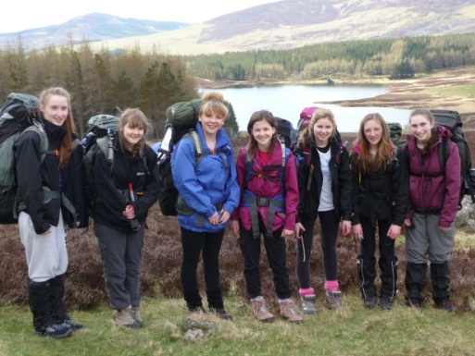This is an area where we would welcome help from volunteers from the community. Expedition training happens in the lunch hour or after school. Volunteers would be interested in hill walking and camping. The young people are very pleasant and fun to work with in this context.  Of course, all volunteers, like staff at school, are vetted under the Council's Protecting Vulnerable Groups scheme

We appreciate everyone's help in this worthwhile experience.

**We Will Rock You**

Advance notice, the musical – ‘We Will Rock You’ will run for three nights in June 2014. Pupils have already auditioned and are rehearsing every week to put on a tiptop West End production. Mr Latto, Mrs Edgar, Mrs Longden, Mr Brand, Miss Grundy, Miss Kleppang, Mrs Neill, Ms Branney, Mr Judge, Mr Robertson, Mrs Will Mr Morrison and Mr MacCrimmon from the Expressive Arts Department are heavily involved in this production and are also working extremely hard to get the final preparations for our Christmas Concert complete before Thursday 17th December.

There are many extra curricular activities including the following: Scripture Union, Book Club, Debating Club, Acting Class, Art Class, Golf league, Football, Cricket, Rugby, Table-Tennis, Dance, Badminton, Zumba, Cheerleading, Hockey, Basketball, Athletics, Swimming and Volleyball a schedule of activities is available on the website.

**Improving Communication with Parents**

As I said in my introduction, we try very hard to keep parents regularly informed about what’s going on at the school. However, I realise that letters occasionally remain in schoolbags rather than reaching you.

We are also increasingly aware of the substantial cost and environmental impact associated with the amount of paper and photocopying involved. To help improve these areas we hope to make increasing use of our website and other electronic communication. Our Captains are going to pilot the use of Twitter and are visiting other schools that are already using it to increase effective communication. We feel that this has the potential to give parents information more quickly, more regularly and more effectively. We can tell you more about what’s going on at the school very quickly e.g. Extreme Weather days.

We will fully consult with our parents and pupils to get your views before we go ahead with any new system.

As I said earlier, we would like to issue future parent newsletters electronically.

To do all of this we will need your e-mail addresses and mobile numbers (some of which we already have).

Please be assured that all information you provide will be kept strictly private and will not be passed on under any circumstances.

Many schools have been contacting their parents electronically for some time now and it has been reported to me that the school and the parents feel it is a very productive way of communicating.

I recognise that some parents may have concerns regarding this. If you wish to discuss the proposal with me, please contact me at the school.

It is planned that we add a space for email addresses when we put out the ‘data capture’ forms in the new session.

As ever, if there are any issues contained within this newsletter you wish to discuss please contact me at the school.

Yours faithfully



Mrs McInally

Head Teacher

**Parent Council News**

Your Parent Council have been working closely with the School across a range of initiatives:

* Lobbying for an improved transport service to help more of our rural based pupils take part in after schools clubs and activities;
* Providing regular feedback on the recently introduced Tracking Reports across S4, 5 & 6;
* Assisting staff to develop a range of parent friendly study guides across all subject areas;
* Maintaining a keen interest in progress being made with the new qualifications system for this year - National 4 and 5; and
* Reviewing proposals for new course structures, timetables and choices.

In the New Year we are planning to jointly set up a new network - '*Friends of Monifieth High' -*similar to those operated by many of the leading state schools across Scotland. To get this started we are looking for some volunteers to come forward and help.  We would love to hear from you and our email address is [monParentCouncil@monifiethhigh.angus.sch.uk](mailto:monParentCouncil@monifiethhigh.angus.sch.uk).

The next Parent Council meeting will be on Tuesday 28th January  2014 in the School Library at 7pm.  Everyone is welcome. Please email or drop a note into the School Office with your questions or feedback at any time.

On behalf of all the members of the Parent Council, I would like to wish you and your families a happy Christmas and peaceful New Year.

David Hamilton

Chair, Parent Council

Monifieth High School

C:\Users\montaylore\AppData\Local\Microsoft\Windows\Temporary Internet Files\Content.IE5\F65E7M5V\MC900053668[1].wmf